**Design Choice for Battery**

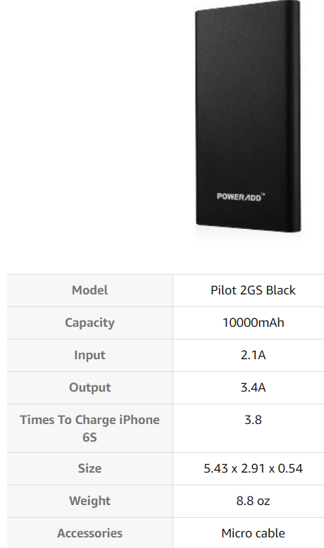

* 24-Hour Current Requirement:
  + Our system for lab 5 draws **73 mA** on average while playing music.
  + Given a 10,000 mAh battery, the amount of time that we can play music continuously is:
$$t_{max}=10,000\frac{mAh}{73 mA}=136.99 hours=5.71 days$$

* Mechanical Considerations:
  + Size: 5.43” x 2.91” x 0.54” is can fits directly under our PCB.
  + Weight: 8.8 oz is relatively lightweight.